Centerview Partners: The Complete Career Guide
Meta description: WSG founder Stephen Turban explains Centerview Partners: the firm, the three-year analyst program, pay, the Summer Analyst cycle, interviews and exits.

Senior spring at Harvard, a classmate of mine, call him Nate, turned down two bulge bracket offers for an analyst seat at Centerview Partners. I was headed to McKinsey, so I watched his first year the way everyone outside banking watches it: through what he could and couldn't do. He missed a wedding in October. He answered a text from the previous Tuesday at 1:40 in the morning. And twice that year a deal he'd gone quiet about turned up in the news with Centerview's name in the advisor line, weeks after he'd stopped saying anything about his week.

The part that surprised me came in his second summer. The rest of the banking crowd from our class was taking headhunter calls for private equity. Nate didn't take any. The program was three years, not two, the pay was already at the top of the street, and the partner he worked for had told him, more or less in those words, that he'd rather promote him than replace him. He stayed.

I'm Stephen Turban. I went to Harvard, spent two years at McKinsey, and now run WallStreetGuide, where I watch undergrads go after seats like Nate's every cycle. This guide is the one I'd send a sophomore who asked me what Centerview actually is, what it pays, how it hires, and whether a three-year program with no private equity exit built in is a trap or a gift.

What is Centerview Partners known for?
Centerview is an independent advisory firm: it advises companies and boards on mergers, sales, takeover defense, activism and restructurings, and it does nothing else. No lending, no trading, no underwriting. Centerview is known for advising the client on the biggest deal of the year more often than its size would predict, and for paying its analysts more than any bulge bracket. Founded in 2006, it was lead financial advisor to Paramount on the $110 billion acquisition of Warner Bros. Discovery in 2026 and has been voted the No. 1 investment bank to work for in Vault's survey year after year [VERIFY: Vault 2026 ranking released June 24, 2026; the firm's careers page counts the streak at six years and its home page at seven].

How much do Centerview Partners analysts make?
More than analysts anywhere else on Wall Street, by most reports. Centerview raised first-year analyst base pay to $130,000 in January 2022, when most bulge brackets were at $110,000, and the gap is bigger once the bonus lands. [VERIFY: Financial News, January 11, 2022; confirm the current base] Litquidity's 2023 pay survey put the average Centerview analyst at about $205,000 in salary plus bonus, and Wall Street Oasis entries average about $226,000 in total pay across 42 self-reported analysts, with a range from $135,000 to $390,000 [VERIFY: eFinancialCareers citing Litquidity, February 2026; WSO salary page, October 2026]. Section 3 breaks the pay stack down year by year.

1. Centerview is a 2006 startup that now sits on the biggest deals in the world
Start with how the firm came to exist, because the founding story explains the business model.

Blair Effron spent ten years at Dillon, Read and stayed through the mergers that folded it into UBS, where he became Group Vice Chairman of the investment bank. Robert Pruzan had been President of Wasserstein Perella, the M&A boutique of the 1990s, and then ran investment banking as CEO of Dresdner Kleinwort Wasserstein's North American business. Before any of that, Pruzan was a McKinsey consultant, which I'll admit I enjoy telling students who think the two careers never touch. In 2006 the two of them left the big banks and co-founded Centerview in New York. [VERIFY: founder bios on centerviewpartners.com]

The founders' bet was that a chief executive would rather take advice from a senior banker with no products to sell than from a bank that also wants to lend to the buyer. Twenty years on, that bet looks right. The firm says it has advised on roughly $4 trillion of transactions since 2006 and counts a fifth of the world's 50 largest companies by market value as clients [VERIFY: firm's own figures, centerviewpartners.com, October 2026]. The Wall Street Journal reported revenue of about $1.9 billion in 2024, up from $1.5 billion in 2023, and a 5.35 percent share of US M&A advisory fees, fourth among all banks [VERIFY: WSJ, January 2025, via Capital Brief]. Spread $1.9 billion across roughly 80 partners and you get about $24 million of revenue per partner, which is the arithmetic behind the pay in Section 3.

What the firm does, in plain words

Centerview has six capability lines on its website: strategic advisory (buying and selling companies), restructuring and recapitalization (fixing a company that can't carry its debt), independent board advice, special committees (a group of independent directors set up when the full board has a conflict, such as a sale to its own controlling shareholder), shareholder activism and capital advisory. In practice the first one is most of the revenue. The firm doesn't lend, doesn't trade, doesn't run equity research and doesn't underwrite stock or bond offerings. When a client needs debt to pay for a deal, Centerview advises on the structure and a bank with a balance sheet provides the money.

Offices and size

Five offices: New York (the headquarters, at 31 West 52nd Street), London, Paris, Menlo Park and San Francisco [VERIFY: centerviewpartners.com office list, October 2026]. The Wall Street Journal counted about 80 partners and roughly 500 professionals in 2020, and still reported about 80 partners in January 2025 [VERIFY: WSJ, December 23, 2020 and January 2025; current headcount is not published]. For an analyst, the number that matters is the ratio: one partner for every six or so people in the building. At a bulge bracket you can go a year without a managing director knowing your name. At Centerview the partner is on the call.

The deals Centerview is known for

Here are six mandates where Centerview's role is spelled out in the press release or the merger filing, not in a league table summary.

Announced | Centerview's client | The deal | Size | Centerview's role
February 27, 2026 | Paramount Skydance | Acquisition of Warner Bros. Discovery at $31 a share in cash | $110 billion enterprise value, $81 billion equity | Lead financial advisor with RedBird Advisors; BofA, Citi, M. Klein and LionTree also advised
May 21, 2026 | Equity Residential | Merger of equals with AvalonBay Communities | About $69 billion enterprise value | Lead financial advisor alongside Morgan Stanley
November 3, 2025 | Kenvue | Sale to Kimberly-Clark at $21.01 a share in cash and stock | About $48.7 billion enterprise value | Financial advisor with Goldman Sachs (sell side)
July 9, 2025 | Verona Pharma | Sale to Merck at $107 per ADS | About $10 billion | Exclusive financial advisor (sell side)
January 13, 2025 | Intra-Cellular Therapies | Sale to Johnson & Johnson at $132 a share | About $14.6 billion equity value | Financial advisor with Jefferies (sell side)
February 14, 2013 | H.J. Heinz | Sale to Berkshire Hathaway and 3G Capital at $72.50 a share | $28 billion including debt | Financial advisor with BofA Merrill Lynch (sell side)

[VERIFY: each row against the cited press release or 8-K; Paramount closing (expected October 6, 2026, with the combined company to be called Skydance) and the Kenvue closing (Kimberly-Clark said on October 1, 2026 it expects the fourth quarter of 2026) are pending as of October 5, 2026]

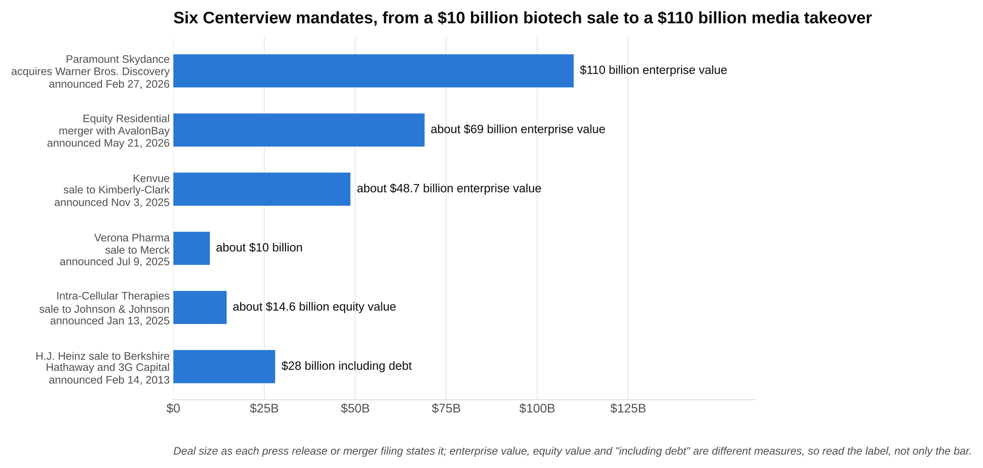
Centerview's role on all six is spelled out in the press release or merger filing, and the sizes run from $10 billion to $110 billion.

Three things to notice in that table. The firm is usually on the sell side or the board's side, where independence is the product. The deals are enormous relative to the firm's size. And the sectors jump around: media, apartments, consumer health, biotech, ketchup. Centerview's own transactions page listed 91 announced mandates dated 2026 as of early October, from a $110 billion media takeover to a $4 billion Ecuador bond issue to a $2.25 billion Clorox acquisition, which is why its analysts are generalists. [VERIFY: centerviewpartners.com/transactions.aspx, October 5, 2026; Santander's Webster deal at $12.2 billion and Masimo's $9.9 billion sale to Danaher are on the same page]

The Paramount deal is worth a minute because it's the kind of mandate the firm is built for. Paramount launched an all-cash hostile offer for Warner Bros. Discovery at $30 a share on December 8, 2025, three days after WBD's board had endorsed a $27.75 a share deal with Netflix for its studio and streaming business. Centerview and RedBird were the advisors behind that bid. Netflix declined to raise in late February, WBD's board called Paramount's improved $31 offer superior, and the signed deal was announced on February 27, 2026. Shareholders approved it on April 23, 2026, the Justice Department cleared it in June, twelve state attorneys general sued in July, and a settlement announced September 21 and approved by a judge on September 30 cleared the deal to close, with the combined company to take the Skydance name [VERIFY: Paramount press release February 27, 2026; TechCrunch October 2, 2026; closing expected October 6, 2026]. A hostile bid against a signed deal, a board process, a shareholder vote, two regulators and a lawsuit, over ten months. An analyst on that team saw more of a career's worth of M&A than most bankers see in five years.

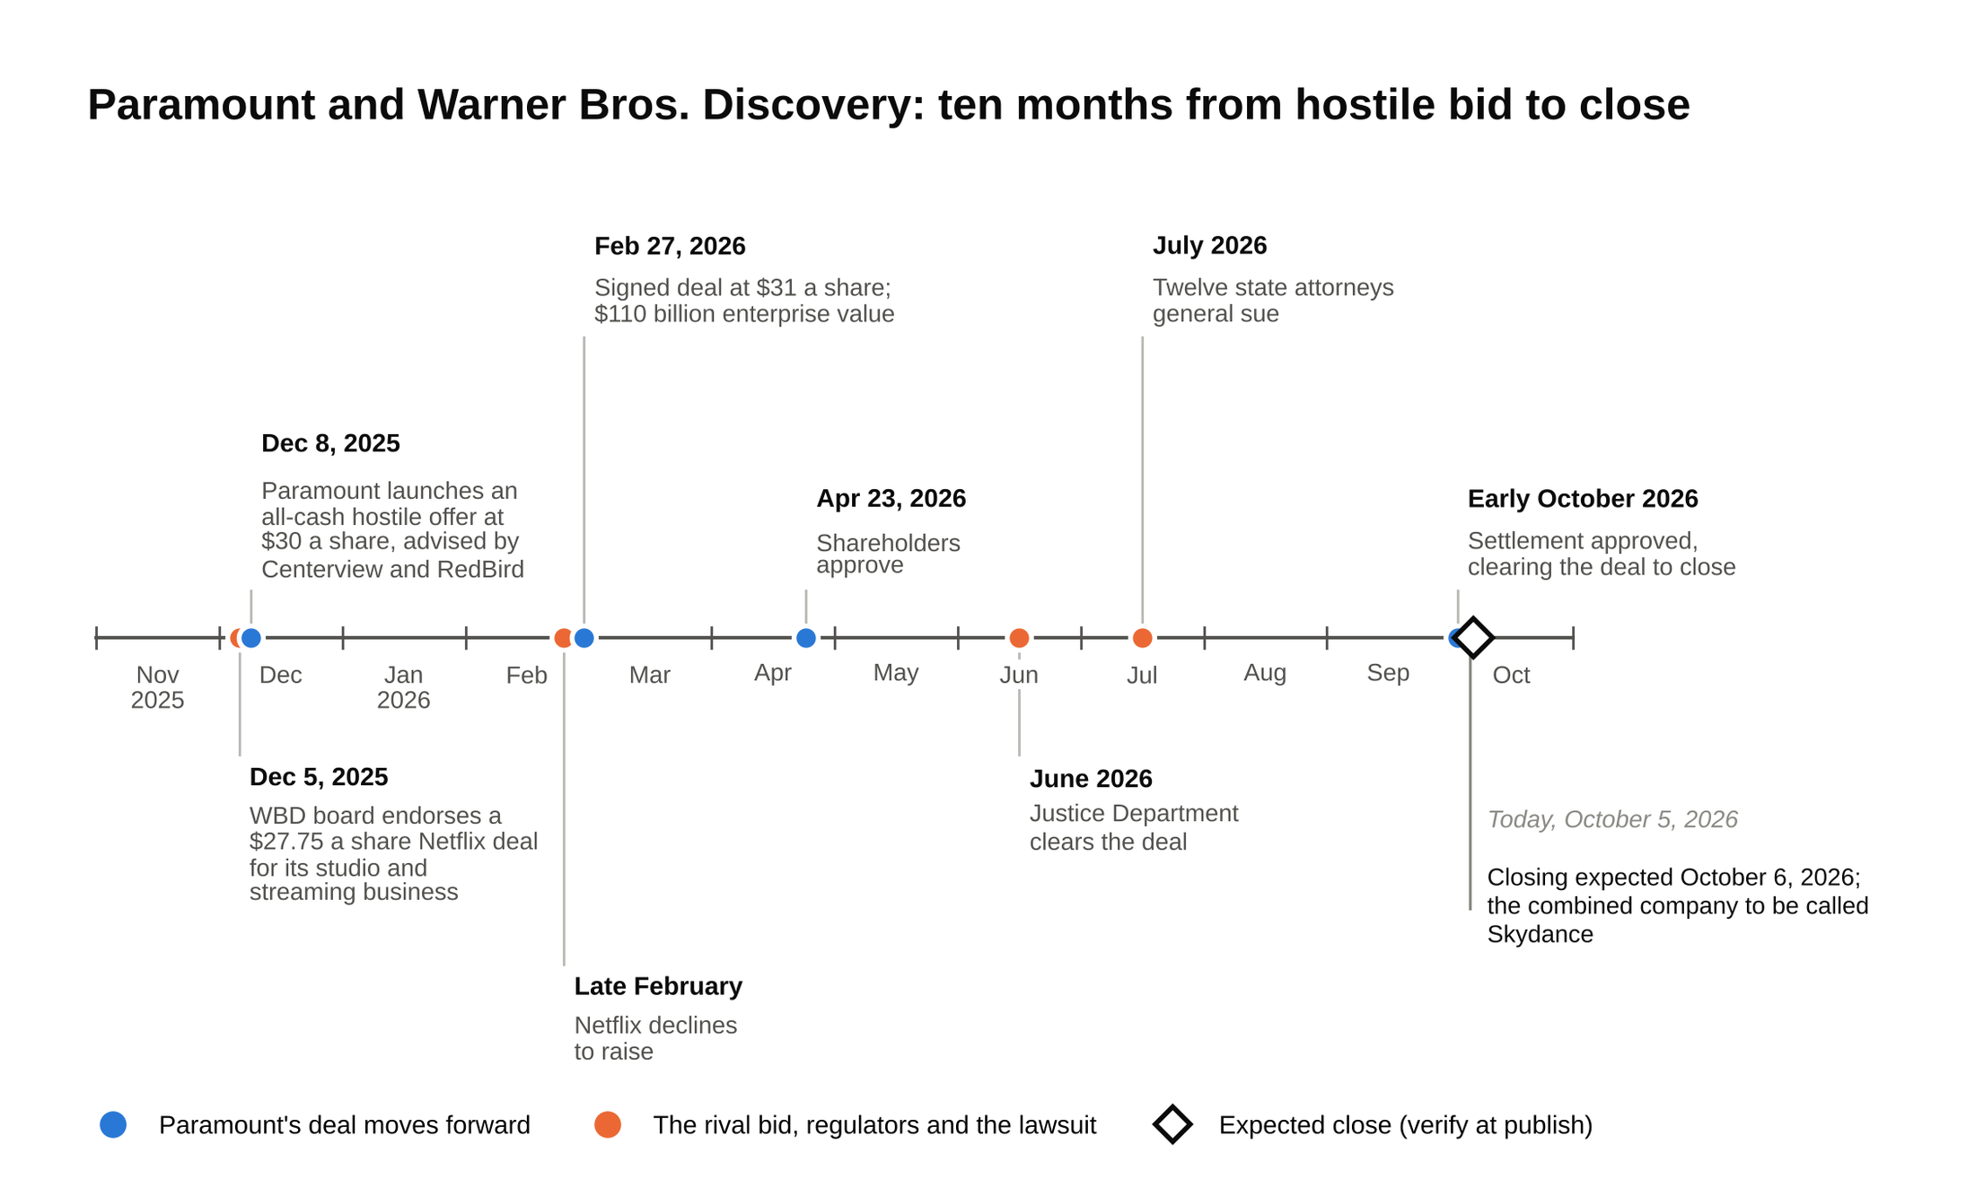
A hostile bid against a signed deal, a board process, a shareholder vote, two regulators and a lawsuit, and the close is expected the day after this guide's date check.

Why a client pays a firm with no balance sheet

A sophomore usually asks this backwards: why would a company hire a bank that can't lend it money? Walk it from the board's seat.

A public company's board is deciding whether to sell the company. Its usual bank also lends to the likely buyer, runs the buyer's bond deals and would love to finance the acquisition. That bank's advice on price carries a conflict the board can see. So the board hires an advisor with nothing to sell except the advice. The advisor runs the process, negotiates the price and writes the fairness opinion, the formal letter telling shareholders the price is fair, which the board needs to defend itself in court if someone sues. For that letter to mean anything, the firm writing it can't have a financing fee riding on the answer.

Then the second reason: who actually does the work. At Centerview the partner who won the mandate sits in the negotiation. At a big bank the senior banker who pitched often hands the deal to a vice president and moves to the next pitch. Chief executives notice.

Independence sells because boards get sued, and a fairness opinion from a firm with no financing fee on the deal is worth more in court than one from the buyer's lender. The trade-off is real too. A client that needs $20 billion of debt also hires a bank that can commit it, which is why Paramount's advisor list had BofA and Citi next to Centerview.

2. How Centerview differs from a bulge bracket and from the other elite boutiques
Our guide to the top M&A investment banks ranks the firms. This section is about what the differences do to an analyst's day.

Against a bulge bracket

At Goldman, JPMorgan or Morgan Stanley an analyst joins a coverage group (healthcare, TMT, industrials) or a product group (M&A, leveraged finance, equity capital markets) and stays there. The group has a staffer who assigns work, a deal team of six to ten people, and a pipeline that includes financings, IPOs and pitches that never become deals. The analyst's job is a slice of a large machine.

At Centerview there is no coverage group for an analyst to join. Analysts are generalists: the staffing goes by who's free, not by sector. A deal team is often a partner, a vice president or associate, and one or two analysts. A Centerview analyst does the work that a bulge bracket spreads across two or three people, on fewer deals, each of which is more likely to close. The flip side is that there's less of a machine around you. Fewer formal training modules, no equity research desk to call for a model, fewer peers in your class to split work with.

Against the other elite boutiques

Students lump the elite boutiques together. They aren't the same firm.

Firm | Founded | Ownership | What makes it different for an analyst
Centerview | 2006, New York | Private partnership | Generalist three-year program, the smallest class, pure M&A and board advisory, top-of-street pay
Evercore | 1995, New York | Public (NYSE: EVR) | Largest independent by revenue, about $3.9 billion in 2025; coverage groups, equity research, a big restructuring practice
PJT Partners | 2015, New York | Public (NYSE: PJT) | Spun out of Blackstone's advisory arm; the deepest restructuring group of the set, plus a separate business raising capital for private funds
Moelis & Company | 2007, New York | Public (NYSE: MC) | Generalist-leaning but larger, with more middle market and sponsor work
Lazard | 1848, New Orleans; now New York | Public (NYSE: LAZ) | Oldest, global, with a large asset management arm alongside advisory
Qatalyst Partners | 2008, San Francisco | Private | Technology only; a tech sell-side specialist rather than a generalist shop
Perella Weinberg | 2006, New York | Public (Nasdaq: PWP) | Advisory plus restructuring, energy strength in Houston, roughly 700 people

[VERIFY: founding dates, listings and the Evercore 2025 revenue figure against each firm's site and filings]

Two differences matter most for a sophomore choosing where to apply. First, sector. Evercore and PJT let you aim at restructuring or a coverage group; Centerview makes you a generalist for three years whether you like it or not. If you already know you want restructuring, our Evercore interview guide covers the firm that lets you say so. Second, ownership. Five of the seven firms in that table report earnings to public shareholders. Centerview doesn't, which is part of why it can pay analysts the way it does and why it can run a three-year program without anyone asking about headcount costs on an earnings call.

Centerview is the elite boutique with the fewest seats, the least structure, the broadest deal exposure and the highest pay, and all four come from the same decision to stay small and private.

3. The analyst program is three years, generalist, and built to keep you
Lead with what the firm wants. Its careers page says, in its own words, that "our hope is that our analysts will choose to stay with us beyond their analyst years," and that it commits "additional resources to provide an analyst experience that is head-and-shoulders above traditional two-year programs." The firm's line is "Bankers at Centerview Partners are made, not born." [VERIFY: centerviewpartners.com careers page, October 2026] Read that as a business plan, not a slogan: the firm would rather train and keep an analyst than rehire from scratch, and it has set up the program so that leaving costs you something.

The three years

Most banks run a two-year analyst program and treat the second summer as the exit. Centerview's runs three. You start as a generalist and stay one. The first year is learning the tools on live deals: the model, the board book, the data room. The second year is the year other banks' analysts spend recruiting for private equity; at Centerview it's the year you own the model and the first draft of the board book, and the year you're the one on the phone with the client's finance team. The third year is a long audition for the associate promote, and the work starts to look like an associate's: checking the first-year's model, running the data room, drafting the process letter that tells bidders how the sale will run.

The pay stack

Line | Figure | Source
First-year base | $130,000 | Financial News, January 2022 [VERIFY: current base]
Analyst all-in (base plus bonus), average across the analyst years | About $205,000, per Litquidity's 2023 survey | eFinancialCareers, February 2026 [VERIFY]
Analyst total pay, self-reported | About $226,000 average across 42 entries; range $135,000 to $390,000 | Wall Street Oasis, October 2026 [VERIFY]
Analyst-to-associate retention bonus | $200,000, paid to analysts promoted to associate, contingent on staying at least two more years | Bloomberg, June 3, 2021 [VERIFY: whether the program still runs]
Bulge bracket first-year base, for comparison | $110,000 to $120,000 | Goldman at $110,000 as of 2026 [VERIFY: firm by firm]

Read the table from the bottom up. A bulge bracket first-year analyst on $110,000 base with a mid-bucket bonus clears somewhere around $160,000 to $180,000 all-in [VERIFY: 2026 bonus season]. A Centerview analyst is reported at about $205,000 on average, and the self-reported range runs well above that. The reported gap between a Centerview analyst and a bulge bracket analyst is roughly a bulge bracket bonus, every year, before you count the $200,000 the firm has offered analysts who stay on as associates.

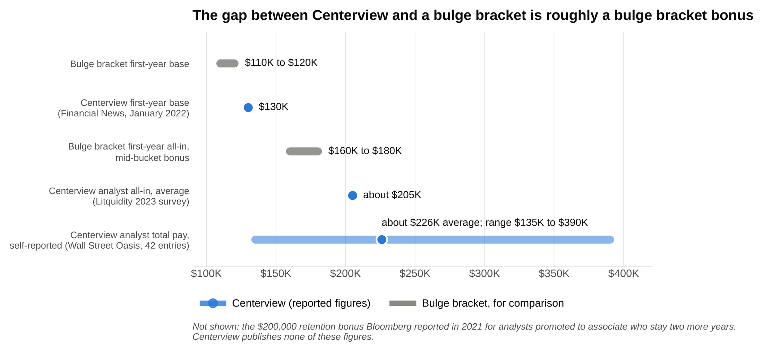
Centerview's base is $20,000 above a bulge bracket's, and the reported all-in figures sit well above a bulge bracket's $160,000 to $180,000.

Two warnings about pay numbers. Centerview doesn't publish them. Every figure in that table is from a reporter or a forum, and the firm has no reason to correct the forum. Treat the base as firm, the all-in as a range and the retention bonus as a 2021 data point that may have changed.

Why the pay is possible

A public bank's analyst pay is a line item that shareholders can see on the earnings call. Centerview's is a private decision by about 80 partners, and revenue per employee was reported at about $3.5 million [VERIFY: eFinancialCareers, January 2025, citing WSJ]. When each banker generates that much, paying the most junior ones $200,000 is cheap retention.

Private equity recruiting

Here is the part students argue about most. On-cycle private equity recruiting now starts within months of an analyst's first day. Headhunters email first-years in the summer or fall, interviews happen in a sprint, and offers are for a job that starts two years later. The practice got so aggressive that JPMorgan told its 2025 incoming analysts that accepting a future-dated offer in the first 18 months would end their employment, and Apollo said it would skip formal on-cycle interviews for its 2027 class [VERIFY: Fortune and Bloomberg reporting, June and July 2025].

Centerview has never needed a letter like JPMorgan's. The three-year program, the direct promote and the pay do the same job. Centerview doesn't publish a policy on private equity recruiting, but analysts and prep forums have reported for years that the firm discourages first-year on-cycle recruiting and expects analysts to finish the program. [VERIFY: no firm statement exists; confirm the current stance with analysts in the class ahead of you] Nate's version, from the inside, was simpler: nobody told him he couldn't, and everybody made it clear what they thought of it.

What that means for you: if your plan is two years of banking and then a megafund, Centerview is the wrong firm to execute it at, and you'll be the one explaining that choice in a "why Centerview" interview. If your plan is to become a banker, or to decide later with a three-year resume that every headhunter recognizes, it's the right one.

What an analyst actually does

The work is M&A work: building the valuation (comparable companies, precedent transactions, a discounted cash flow), the merger model that shows what the buyer's earnings look like after the deal, the board book that walks directors through the options, and the process documents when the client is selling. On a sell side, that's the teaser, the confidential information memorandum, the management presentation and the data room. On a buy side, it's the bid letters and the model behind the price.

What's different is who's in the room. With two or three people on a deal team, the analyst builds the model and presents parts of it, sits in on the board call rather than hearing about it, and gets edits from a partner rather than from a second-year analyst. A Centerview analyst sees the inside of a board process in year one, which at a bulge bracket usually happens in year three or not at all.

Hours

Long, and less predictable than a bulge bracket because the teams are small and the deals are live. When an analyst's 2021 employment lawsuit against Centerview neared trial in 2026, the firm's own court filings described the ability to work unpredictable hours as "an essential role of an analyst" [VERIFY: Banking Dive, February 23, 2026; the case settled before trial]. That's the firm's own description of the job, in a court filing, and it matches what I watched from across a dinner table. Depositions in the same case, as reported by eFinancialCareers, described 60 to 120 hour weeks as the norm, with the worst stretches when a deal is signing [VERIFY: eFinancialCareers, February 20, 2026]. Section 7 goes further.

4. The Summer Analyst program is tiny, early and mostly campus-driven
The Investment Banking Summer Analyst internship is the main door into the firm. Centerview fills its full-time analyst class largely from its Summer Analyst class, so for most students the internship interview is the job interview.

When the Summer 2028 cycle is expected to open

Elite boutiques recruit about a year and a half ahead. For Summer 2027 seats, Centerview's campus recruiting ran in sophomore spring, with applications in January to March 2026 and interviews through the spring [VERIFY: the firm posts no public dates; sourced from school postings and prep-site trackers]. Expect the Summer 2028 cycle to run on the same calendar: applications in January to March 2027, first rounds within weeks of applying, and offers by late spring [VERIFY: Summer 2028 dates once posted]. If you're a sophomore reading this in the fall of 2026, the networking window is now and the application window is three months away. Our 10 IB internships to apply to in 2027 post places the Centerview window next to the rest of the cycle.

What the application asks for

Centerview's own careers page has one form: name, email, phone, a resume upload, a free-text comments box, a category (the one you want is "Undergraduate interested in Summer Internship") and one office. The page says plainly that "applications for multiple offices will not be reviewed," and asks that you "not send unsolicited emails to multiple people at the firm." Campus postings through your school's portal may add a transcript and a short written prompt [VERIFY: 2027 campus posting requirements]. There is no cover letter upload on the firm's form.

That comments box is the cover letter. Treat it as the "why Centerview" question in writing: three or four sentences that name a deal, a person you spoke to, and the three-year program. Our IB resume template is the format to attach; the resume gets read by a partner, not a screening tool, so the one-page discipline matters more here than almost anywhere.

Target schools and the rest

The firm's words: "We recruit formally on a number of undergraduate campuses, as well as informally from a broad range of schools," and "we are open to candidates from all schools and academic disciplines." The formal campus list is short and skews to the Ivy League, Stanford, Wharton and a few others, and the class is small enough that the Vault internship listing for the New York office gives the intern count as fewer than ten [VERIFY: Vault internship listing; the firm doesn't publish class size]. Centerview's Summer Analyst class is small enough that a single referral from a current analyst moves your odds more than at any bulge bracket.

For a non-target, "informally" is the operative word. The firm's form accepts anyone. What gets a non-target resume read is a current analyst or associate forwarding it with a sentence attached. That means two or three real conversations with people at the firm before you apply, a resume that shows you can already do the technical work (a modeling course finished, a prior finance internship, a student fund with a real pitch), and a comments box that proves you understand the three-year model. Section 9 covers the outreach.

5. The interview process is short, technical and partner-heavy
Centerview doesn't publish its process. What follows is the pattern reported by candidates across recent cycles, and it matches what the firm's structure would predict: few rounds, senior interviewers, and a technical bar set by people who do the work themselves [VERIFY: reported process; confirm with your school's recent candidates].

First round

A 30 to 45 minute phone or video interview with an analyst or associate, sometimes a vice president. It opens with your story for about three minutes and moves to technicals fast. The questions are the standard set at a higher depth: walk $10 of depreciation through the three statements, then do it again at a 25 percent tax rate, then explain what changes if the company can't use the tax deduction this year. A discounted cash flow walk with the follow-up on why you'd use a mid-year convention (the adjustment for cash arriving through the year rather than all on December 31). An enterprise value to equity value bridge with numbers in it. Accretion and dilution with numbers in it.

The superday

Three to six interviews over a half day, and at Centerview that often includes partners, not only vice presidents and associates. Each interview runs 30 to 45 minutes and alternates between technical and fit. Centerview superdays put partners in the room, so the fit questions are blunter than at a bulge bracket and the answers have to fit a three-year program, not a two-year one. Expect: why advisory, why not a bulge bracket, why three years, what would you do if a megafund called in your first October. Offers have been reported within a day or two of the superday, with short decision windows [VERIFY: reported timing].

The technical bar

Centerview's technical bar is higher than most bulge brackets because the interviewer asking the question built the merger model last week. The difference is depth, not breadth. A bulge bracket first round asks you to define accretion and dilution. A Centerview interviewer gives you two companies and a purchase price and asks whether the deal accretes, then changes the mix of cash and stock and asks again. The six questions in Section 6 are built on that pattern.

"Why Centerview" and "why advisory"

The two answers have to be different. "Why advisory" is about the model: independent advice, boards and special committees, deal teams of three, no balance sheet. "Why Centerview" is about this firm against Evercore, PJT and Moelis: generalist staffing, the three-year program, the private partnership, a deal you actually read about. Interviewers at a firm that hires a handful of interns per office can tell when the answer was written for Evercore and search-and-replaced.

The behavioral style

Short and pointed. Expect "walk me through your resume," one or two stories about working on a team under pressure, and a question about a deal in the news. Our 30 IB behavioral questions post covers the structure. The Centerview-specific filter is maturity: can this person sit on a board call in month four without saying anything that embarrasses the partner.

6. A six-question technical mini-drill, answered in full
These are the shapes of question Centerview-style interviewers favor. Every number below is worked out so you can check your own answer against it. Dollar figures are in millions unless noted.

Question 1: accretion and dilution with real numbers

The setup. An acquirer earns $500 million of net income and has 200 million shares at $50 each. A target earns $100 million of net income and the agreed purchase price is $1.6 billion. The acquirer pays half in cash, borrowed at 6 percent, and half in new shares at $50. The tax rate is 25 percent. Pre-tax synergies are $40 million. Is the deal accretive?

Accretion means the buyer's earnings per share go up after the deal; dilution means they go down. First the buyer alone: $500 million divided by 200 million shares is $2.50 of earnings per share, and at a $50 share price that's a price-to-earnings multiple of 20x.

Now the deal, line by line.

Step | Arithmetic | Result
Debt raised | half of 1,600 | 800
Pre-tax interest | 800 times 6 percent | 48
After-tax interest cost | 48 times (1 minus 0.25) | 36
New shares issued | 800 divided by $50 | 16 million
After-tax synergies | 40 times (1 minus 0.25) | 30
Pro forma net income | 500 plus 100 plus 30 minus 36 | 594
Pro forma share count | 200 plus 16 | 216 million
Pro forma EPS | 594 divided by 216 | $2.75
Change versus $2.50 | 2.75 divided by 2.50, minus 1 | 10 percent accretive

So the deal accretes by 10 percent. The follow-ups are where the interview is decided.

Without synergies, pro forma net income is 564, EPS is $2.61, and the deal is still 4.4 percent accretive. All stock with no synergies: 32 million new shares, 232 million total, $600 million of combined net income, EPS $2.59, 3.4 percent accretive. All cash with no synergies: 1,600 of debt costs 72 after tax, net income 528 on the original 200 million shares, EPS $2.64, 5.6 percent accretive.

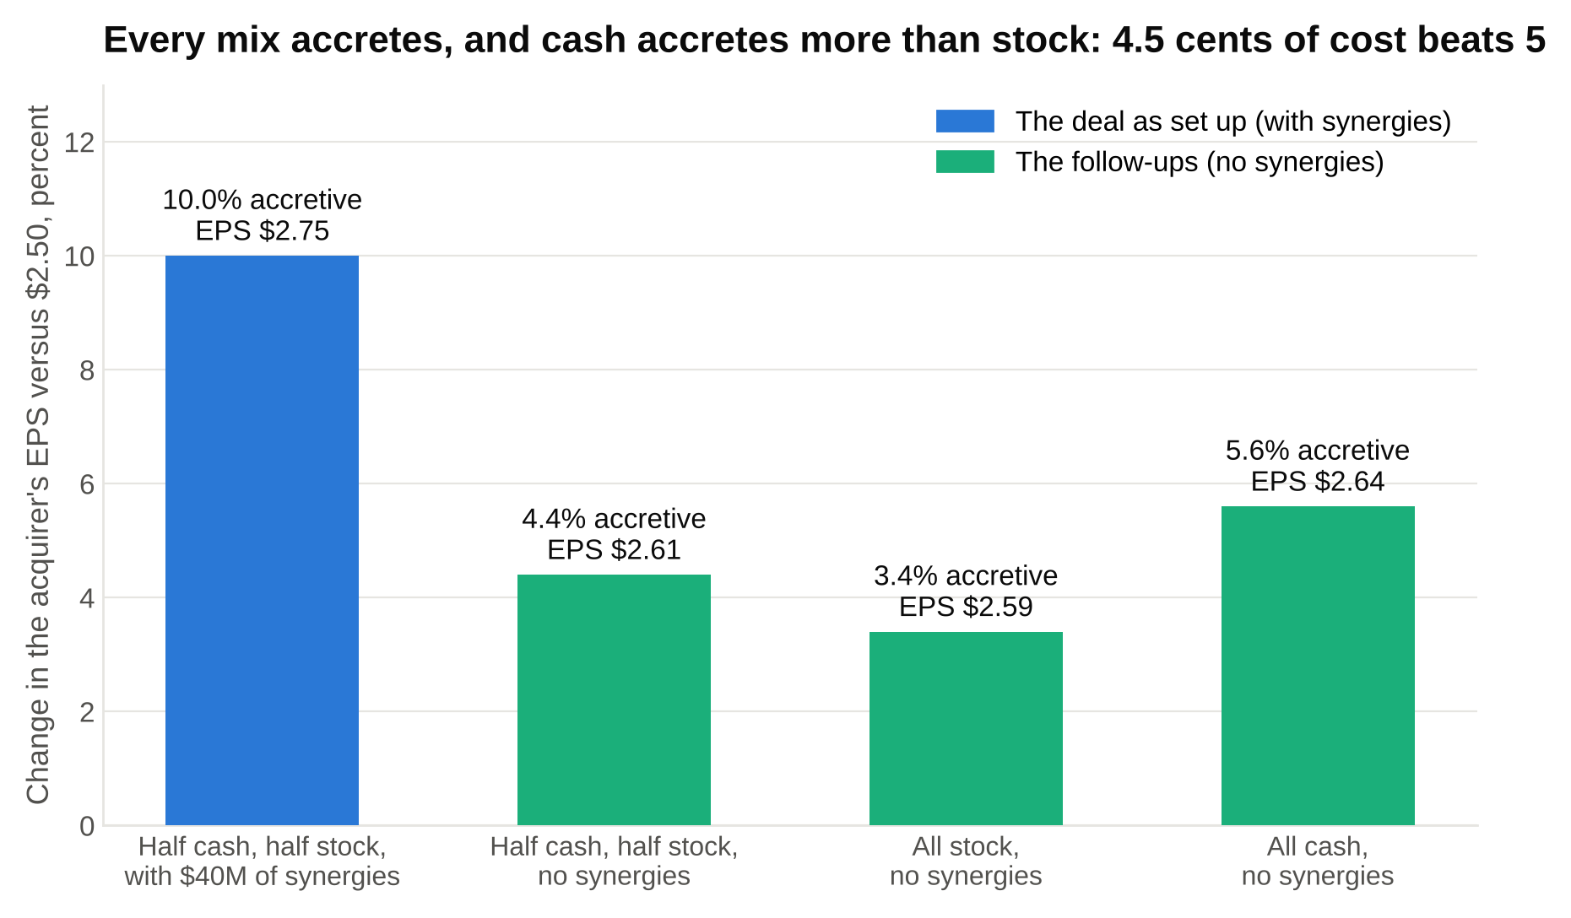
The target earns 6.25 cents per dollar of price, more than either stock at 5 cents or after-tax debt at 4.5, so every mix accretes and all cash accretes most.

The shortcut behind all three results, which the interviewer wants you to say out loud: compare what the acquirer pays for each dollar of the target's earnings with what each dollar costs it. The target costs $1.6 billion for $100 million of earnings, a 16x multiple, so each dollar of purchase price buys 6.25 cents of earnings. Stock costs the acquirer its own earnings yield, 1 divided by 20x, or 5 cents per dollar. Debt costs 6 percent times (1 minus 25 percent), or 4.5 cents per dollar after tax. The target's earnings yield beats both, so every mix of cash and stock accretes, and cash accretes more because 4.5 is cheaper than 5. The all-stock deal stops accreting when the price reaches 20x the target's earnings, or $2 billion, because then the buyer is paying its own multiple.

Question 2: a paper LBO in five minutes

The setup. A sponsor (the private equity buyer) buys a company with $80 million of EBITDA for 8x, using 4.5x of debt at 7 percent interest. EBITDA grows by $8 million a year. Depreciation and capital expenditure are both $10 million a year and cancel. There's no change in working capital. Tax is 25 percent. All free cash flow repays debt. The sponsor sells after five years at the same 8x. What are the multiple of money and the return?

If the structure of an LBO is new to you, read our walk me through an LBO post first. The paper version is the same logic with rounded numbers.

Entry: 8 times 80 is a $640 million purchase price. Debt is 4.5 times 80, or $360 million. Equity is the difference, $280 million.

Each year: EBITDA minus $10 million of depreciation gives EBIT. Subtract interest at 7 percent of the debt you started the year with. Tax the rest at 25 percent. Because depreciation and capex cancel and working capital is flat, net income equals free cash flow, and all of it repays debt.

Year | EBITDA | EBIT | Interest (7 percent of opening debt) | Pre-tax income | Tax at 25 percent | Net income = free cash flow | Debt, end of year
0 | 80 |  |  |  |  |  | 360
1 | 88 | 78 | 25 | 53 | 13 | 40 | 320
2 | 96 | 86 | 22 | 64 | 16 | 48 | 272
3 | 104 | 94 | 19 | 75 | 19 | 56 | 216
4 | 112 | 102 | 15 | 87 | 22 | 65 | 151
5 | 120 | 110 | 11 | 99 | 25 | 74 | 77

Figures rounded to the nearest million at each step, which is what you'd do on a whiteboard.

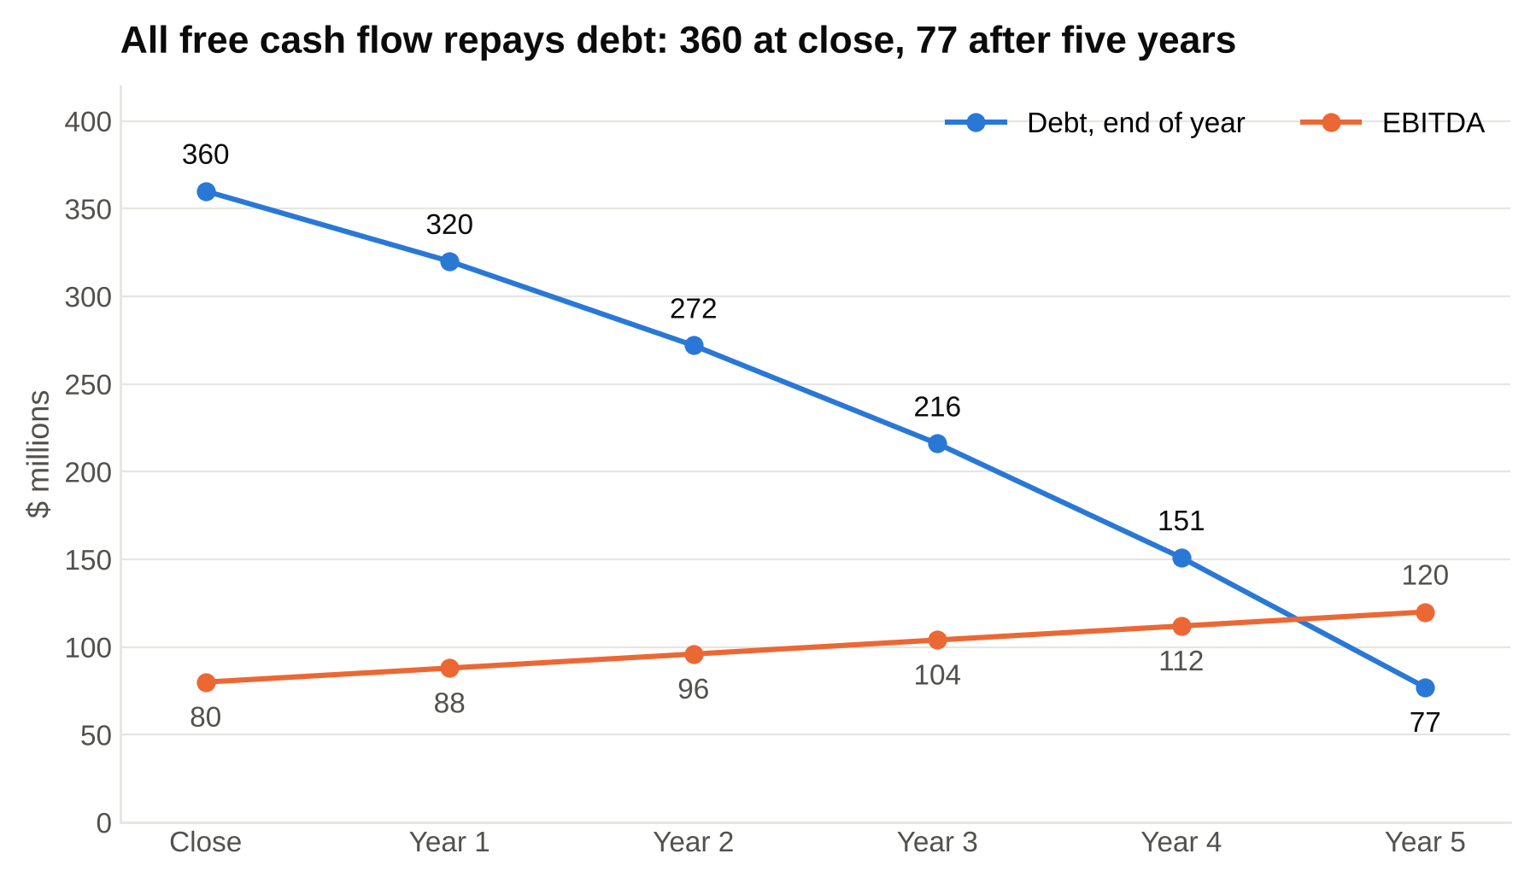
Interest shrinks as the debt does, so each year more of the cash goes to principal, and the paydown speeds up from 40 to 74 a year.

Exit: 8 times the Year 5 EBITDA of 120 is $960 million. Subtract the $77 million of debt left and the sponsor's equity is $883 million. Divide by the $280 million it put in: 3.15x. The unrounded model gives 3.154x and an IRR of 25.8 percent; the rounded whiteboard version lands at 3.15x and, using the rule that 3x over five years is about 25 percent, you'd say "about 26 percent." A paper LBO is scored on whether the chain of arithmetic holds together, not on the second decimal, so say each step out loud and round at every line.

The follow-up to expect: where did the return come from? Three sources. EBITDA grew from 80 to 120, which at a constant 8x added $320 million of enterprise value. Debt fell from 360 to 77, so $283 million of value moved from lenders to the sponsor. The multiple didn't change, so there was no multiple expansion. Together that's $603 million of equity gain, and $883 million minus $280 million is $603 million. It ties.

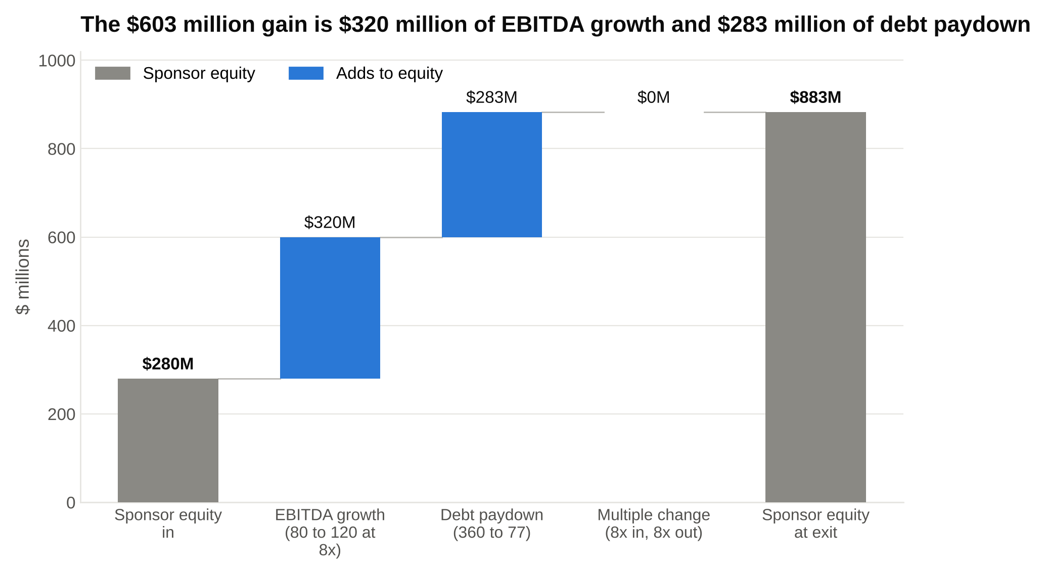
Two sources and no multiple expansion: $280 million plus $320 million plus $283 million is the $883 million the sponsor takes out, and it ties.

Question 3: a terminal value question

The setup. A company's unlevered free cash flow, the cash the business generates before any interest payments, is $100 million in the final projected year, growing 3 percent a year forever. The weighted average cost of capital, the blended rate of return the company's lenders and shareholders require, is 9 percent. What is the terminal value, and what happens if the cost of capital falls to 8 percent?

The terminal value is the value of every cash flow after the projection ends, collapsed into one number with the perpetuity growth formula: next year's cash flow divided by the rate minus the growth rate.

Cost of capital | Next year's cash flow | Rate minus growth | Terminal value | Change
9 percent | 103 | 0.06 | 1,717
8 percent | 103 | 0.05 | 2,060 | plus 20 percent
10 percent | 103 | 0.07 | 1,471 | minus 14 percent

One point of cost of capital moves the terminal value by 20 percent, because the denominator is a small number (6 percent) and a one-point change is a sixth of it. Discount the terminal value back five years and the gap widens: $1,717 million divided by 1.09 to the fifth is $1,116 million, while $2,060 million divided by 1.08 to the fifth is $1,402 million, a 26 percent difference, because the lower rate also shrinks the discount factor.

Then the point the interviewer is really after. With $100 million of cash flow in each of the five projected years, their present value at 9 percent is $389 million. Add the $1,116 million terminal value and enterprise value is $1,505 million. In a typical five-year DCF the terminal value is about three quarters of the answer, which is why interviewers ask what your growth rate and discount rate are before they ask anything else. The cross-check to volunteer: $1,717 million of terminal value on, say, $150 million of Year 5 EBITDA implies an exit multiple of about 11.4x, and if the comparable companies trade at 8x, the 3 percent growth assumption is too generous.

Question 4: from enterprise value to a share price

The setup. A DCF gives an enterprise value of $5 billion. The company has $1.2 billion of debt, $300 million of cash and $100 million of minority interest. There are 200 million basic shares and 10 million options with a $15 strike. What's the implied share price?

Enterprise value is the value of the whole business to everyone who funds it. Equity value is the piece left for shareholders after the other claims. So subtract debt, add back cash (shareholders would get it), and subtract the minority interest (the slice of a subsidiary owned by someone else): 5,000 minus 1,200 plus 300 minus 100 is $4.0 billion of equity value. On 200 million basic shares that's $20.00.

Now the options, by the treasury stock method. At $20 a share, 10 million options with a $15 strike are in the money. Exercising them brings in 10 million times $15, or $150 million, and the company is assumed to use that cash to buy back shares at $20: 7.5 million shares. Net new shares are 10 minus 7.5, or 2.5 million. Diluted shares are 202.5 million, and $4.0 billion divided by 202.5 million is $19.75.

Strictly, the price you used to count the buyback ($20) isn't the price you ended up with ($19.75), so the exact answer solves the circle and lands at $19.76. Say $19.75 and mention the circularity; that one sentence tells the interviewer you've built the bridge rather than memorized it.

Question 5: walk me through a sell-side process

No arithmetic, but the question separates candidates who've read a process letter from those who haven't. The answer in order:

- Preparation (four to eight weeks). The bankers build the valuation, write a two-page teaser that describes the company without naming it, write the confidential information memorandum (the 60 to 100 page book that tells the full story), build the financial model buyers will get, and agree with the board on the buyer list.
- First round (four to six weeks). Teasers go to the list, interested buyers sign a non-disclosure agreement and receive the memorandum, and they submit non-binding indications of interest: a price range, how they'd pay for it, what they'd need to confirm.
- Second round (four to eight weeks). The board picks a shortlist. Those buyers get management presentations, a data room with contracts and detailed financials, site visits, and a draft purchase agreement. They submit final, binding bids with a marked-up contract.
- Negotiation and signing (one to three weeks). The bankers run the final bidders against each other on price, certainty and terms, the board approves the winner, the fairness opinion is delivered, and the agreement is signed and announced.
- Signing to closing (three to twelve months). Regulatory approvals, a shareholder vote if the seller is public, financing, and any litigation.

The Centerview follow-ups: what does a buyer's bid letter say besides price (financing sources, approvals needed, timing, conditions), what makes a board pick a lower bid (certainty of closing), and how is a special committee process different (the committee hires its own advisor and the conflicted party is walled off). The Paramount timeline in Section 1 is a worked example of the last stage.

Question 6: what is a fairness opinion and why does it have to be independent?

A fairness opinion is a letter from a financial advisor to a board stating that the price in a transaction is fair, from a financial point of view, to the shareholders the board represents. Behind the letter is an analysis the board can point to if a shareholder sues: comparable companies, precedent transactions, a DCF, the premium paid, sometimes a leveraged buyout analysis to show what a sponsor could pay.

Why it has to be independent is the whole case for Centerview. If the advisor writing the opinion also stands to earn a financing fee if the deal happens, or a larger success fee at a higher price, the opinion carries that incentive and a court can discount it. Boards therefore often hire a second, independent firm for the opinion, or hire an independent firm to run the whole process. A fairness opinion is only as useful in court as the advisor's incentives are clean, which is the business Centerview sells. If an interviewer asks why clients pay a boutique when a bulge bracket could do the work, this is the answer with a mechanism attached.

7. Culture, hours and the honest read
Here is the trade, stated plainly.

What you get: a small class, a partner on your deals, generalist exposure across more sectors in three years than most bankers see in ten, pay at the top of the street, a direct path to associate, and a name that every private equity headhunter and hedge fund recruiter recognizes.

What you give up: predictability, structure, sector choice and the two-year clock. Deal teams of three mean that when a partner needs a board book by Monday, the analyst is the one who builds it. The firm's own court filings in 2026 called unpredictable hours an essential part of the role [VERIFY: Banking Dive, February 23, 2026]. There's less formal training than at a bulge bracket, and fewer peers to learn from in your class. You don't pick healthcare or TMT; staffing picks for you. And if you want private equity on the on-cycle timeline, the firm will be pulling the other way.

The students who do well at Centerview are the ones who wanted to be bankers before they wanted to be bankers for two years, and the ones who struggle are the ones who took the seat for the brand and planned to leave in 24 months. Nate was the first kind. Two of the people from our class who went to other elite boutiques with a two-and-out plan were miserable in a way he never was, not because the hours were different but because every month at a firm that wants you to stay feels like a negotiation when you've already decided to go.

A note on the Vault ranking, since the firm leads with it. Vault's survey asks bankers to rate their own firm on culture, hours, pay and training and to rate other firms on prestige, and about 2,100 banking professionals answered the 2026 survey between January 28 and April 17, 2026 [VERIFY: Vault release, June 24, 2026]. Centerview came first overall. Vault's No. 1 ranking means the people at Centerview like working there; it doesn't mean the hours are shorter. Both things are true.

8. Exits: direct promotion, then everything else
The firm's stated hope is that you stay, and the pay and the three-year structure are built around that. The default Centerview exit is the associate promotion at the end of year three, and the firm has paid analysts to take it. Bloomberg reported in 2021 that promoted analysts were offered a $200,000 bonus contingent on staying two more years [VERIFY: whether the program continues]. At a firm that recruits associates from business schools too, a promoted analyst skips the MBA and the two years of tuition and keeps the deal experience.

For analysts who do leave, the destinations reported on forums are the ones you'd expect from the name: large buyout funds, growth equity, and the occasional fundamental hedge fund [VERIFY: forum reports; the firm publishes no placement data]. The timing is the difference. A Centerview analyst who recruits usually does it in year two or year three, off-cycle or in a later on-cycle, with a resume that shows live mandates in the tens of billions. Headhunters know what the name means. A Centerview resume is one of the few in banking that a private equity firm will read without caring which group you sat in, because there is no group.

The honest caveat: fewer exit-timing options. The on-cycle process rewards analysts who are ready in their first fall, and a firm that discourages that puts you a year behind peers at banks that don't. If the plan is a megafund associate seat starting the day your two years end, Centerview makes that plan harder. If the plan is a buy-side seat at some point, with a better resume, it makes it easier.

9. How to network into Centerview, and what to say when you get there
With a class this small and a firm this senior, the path in is people. Three rules.

Reach out to analysts and associates, one at a time, and never to several people at once. The firm's careers page asks you not to email multiple people, and in a firm of a few hundred, a partner hearing that the same sophomore wrote to four bankers in one week isn't the impression you want. Pick one person, through your school's alumni directory or a mutual connection, and write a four-sentence email: who you are, one specific reason you're writing to them (a deal they worked on, a club you share), one question you actually want answered, and a request for 15 minutes.

Ask about the three-year program and the generalist model, not about exits. The right questions: what did your second year look like compared with your first, how does staffing decide which deal you get, what did the partner on your last deal expect from you in the first month. The wrong question: how is on-cycle recruiting from here. Everyone at the firm has heard it, and it tells them your plan.

Ask for one specific thing at the end of the call, and make it easy. The ask is "would you be comfortable passing my resume along when applications open," not "can you refer me." Then follow up when the application opens, with the resume attached and a two-line note on what you've done since the call.

The outreach timeline for a sophomore targeting Summer 2028: two to three conversations in the fall of 2026, a follow-up with each in December, the application in the January to March 2027 window with a referral attached, and technical prep running the whole time so a first-round call in February doesn't catch you mid-course [VERIFY: Summer 2028 dates].

Say this, don't say that

Why Centerview?

Don't say: "Centerview is the most prestigious boutique and pays the most."

Say: "Centerview was lead advisor to Paramount on the Warner Bros. Discovery deal, which meant running a hostile bid against a signed Netflix agreement and then a ten-month process through a shareholder vote and a state lawsuit. I spoke with an analyst who described being on the team for a board process in his first year. I want the three-year generalist program because I want to be a banker, not to pass through one."

Why advisory instead of a bulge bracket?

Don't say: "Boutiques have better culture and smaller teams."

Say: "A board that's selling the company wants advice from a firm that doesn't also want to finance the buyer. That's the product, and the way to learn it is on a team of three where the partner is on the call, which is what I'd get here and wouldn't get in a coverage group of forty."

What would you do if a private equity headhunter emailed you in your first October?

Don't say: "I'd take the call to keep my options open."

Say: "I'd tell them I'm in a three-year program and to reach out in my third year. I chose this firm for the program, and I'd rather recruit later with three years of mandates than earlier with four months."

Walk me through a recent Centerview deal.

Don't say: "I know they did a big media deal this year."

Say: "Centerview advised Kenvue on its sale to Kimberly-Clark, announced November 3, 2025, at $21.01 a share in cash and stock, about $48.7 billion of enterprise value. It was a sell-side mandate alongside Goldman, and the part I'd want to understand is how the board weighed a mixed cash-and-stock offer against staying independent after Kenvue's own spin from J&J."

Is the deal accretive?

Don't say: "It depends on the synergies."

Say: "Compare the target's earnings yield at the purchase price with the after-tax cost of the cash and the acquirer's earnings yield for the stock. If the target's yield is higher than the blended cost, it accretes before synergies. Then I'd check what happens at 100 percent stock, because that's the case closest to breakeven."

What to do this week
If you're a sophomore and Centerview is on your list, you have three months before the Summer 2028 window is likely to open. Spend them in this order. Find one analyst or associate through your alumni directory and ask for 15 minutes. Read the Paramount press release of February 27, 2026 and the Kenvue release of November 3, 2025, and write a paragraph on each in your own words. Work the six questions in Section 6 until the accretion shortcut and the paper LBO come out in order, out loud, without notes.

Then decide the question that matters more than any of that: whether you want three years at a firm that wants to keep you. Nate did, and he's still there. If you don't, there are seven other elite boutiques in the table in Section 2, and the honest answer will serve you better than the prestigious one.

